PROJECT DESIGN PHASE
POCKETSMART AI
Project Design Documentation
Problem–Solution Fit • Proposed Solution • Solution Architecture
Document Item | Details
Project Name | PocketSmart AI
Project Phase | Project Design Phase
Design Basis | Existing PocketSmart AI source code
Application Type | AI-assisted budget planning and recommendation web application
Backend | Python FastAPI
Frontend | HTML, CSS, JavaScript, Jinja2
Database | SQLite
AI Service | Google Gemini API
Security | bcrypt password hashing + JWT authentication
Document Date | 02 October 2026

1. Problem–Solution Fit
PocketSmart AI addresses a common planning problem: users often know the amount they can spend but do not have a structured way to divide that budget across items, compare suitable options and obtain personalised suggestions. The implemented application converts user preferences and budget information into structured plans for home interiors, parties and jewellery.

1.1 Problem Statement
- Budget planning for home interiors, parties and jewellery can require multiple searches and manual calculations.
- Users may struggle to decide how much of a fixed budget should be allocated to different categories.
- Recommendations should consider user preferences such as style, occasion, guest count, metal preference and notes.
- Jewellery selection may depend on an outfit's colour, fabric and style, creating a need for optional image-based assistance.
- AI services can fail or be unavailable, so a useful planner should still produce a basic recommendation.

1.2 Target Users
Target User | Need | PocketSmart Response
Home Planner User | Plan rooms and purchases within a fixed budget | Room-wise item recommendations and budget allocation
Party Planner User | Organise an event based on guests, event type and budget | Catering, venue, decoration and entertainment allocation
Jewellery Shopper | Select coordinated jewellery for an occasion | Jewellery recommendations based on occasion, style, metal and optional outfit image

1.3 Existing Situation vs Proposed Situation
Aspect | Existing / Manual Situation | PocketSmart AI Solution
Planning | User searches many sites and calculates costs manually | Single planner form captures requirements
Budget Allocation | Manual estimation | AI or rule-based engine allocates the budget
Personalisation | Generic search results | Recommendations use entered preferences
Image Context | Manual judgement for outfit matching | Optional outfit image can be analysed by Gemini
Price/Quantity Calculation | Manual calculation | System normalises item price, quantity and section totals
Shopping Discovery | Separate searches | System generates canonical search links
Repeat Planning | Previous plans may be lost | Authenticated history stores recommendations

1.4 Problem–Solution Fit
The solution fits the identified problem because the implemented workflow begins with the user's budget and preferences and ends with an actionable, structured recommendation. The design also reduces dependence on a single external AI service by providing a deterministic fallback recommendation engine.

2. Proposed Solution
PocketSmart AI is proposed as a web-based personal planning assistant. A registered user selects one of three planners—Home, Party or Jewellery—enters a budget and preferences, and submits the plan. The FastAPI backend validates the request, calls Gemini when configured, normalises the returned JSON, calculates budget totals and saves the recommendation. If Gemini is unavailable or returns an unusable result, the built-in catalog/fallback service creates a usable recommendation.

2.1 Solution Components
Component | Purpose
Authentication Module | Registration, login, logout, JWT token generation and session handling
Dashboard Module | Shows total saved plans, category counts and recent recommendations
Home Planner | Collects budget, rooms, items, quantities, style and notes
Party Planner | Collects budget, guests, event type, venue, city and notes
Jewellery Planner | Collects budget, occasion, style, metal, notes and optional outfit image
Gemini AI Service | Generates structured personalised recommendations
Fallback Catalog | Generates rule-based recommendations when AI is unavailable
Budget Normalisation | Calculates quantities, subtotals, totals and budget compliance
Image Service | Validates, resizes and converts uploaded images to JPEG
Recommendation History | Stores, filters, displays and deletes user-owned plans
Search Link Service | Creates safe canonical search links for supported platforms

2.2 Novelty / Uniqueness
- Combines three different personal planning domains in one budget-oriented application.
- Uses structured AI output rather than displaying unstructured model text.
- Supports optional image-aware jewellery recommendations.
- Provides a rule-based fallback so planning remains functional without an AI key or after an AI failure.
- Canonicalises shopping/service platform links instead of trusting URLs returned by the AI model.
- Stores recommendations as reusable history tied to the authenticated user.

2.3 Social Impact / Customer Satisfaction
- Helps users make more organised spending decisions.
- Reduces repetitive search and manual budget calculations.
- Makes personalised planning accessible through a simple browser interface.
- Encourages comparison across supported shopping/service platforms.
- Can help users avoid uncontrolled spending by showing estimated allocations and totals before purchase.

2.4 Business Model / Revenue Model
The current code does not implement payments, subscriptions or advertising, so no revenue mechanism should be represented as an existing feature. A future business model could use optional premium planning features, affiliate referrals from supported shopping links, or subscription-based advanced personalisation. These are future possibilities and are not part of the current implementation.

2.5 Scalability
- The route, service, schema, security and database layers are separated, making future extension possible.
- SQLite can be replaced by PostgreSQL or another production database.
- Local image storage can be replaced by cloud object storage.
- The AI service can support additional Gemini models through configurable primary and fallback model names.
- New planner categories can be added by extending schemas, routes, prompts, fallback logic and templates.
- The current design is suitable for a small-scale project; production scaling would require external database/storage, rate limiting and deployment infrastructure.

3. Solution Architecture
The architecture follows a layered web-application design. The browser presents planner interfaces and sends form or JSON requests to FastAPI. Route handlers apply authentication and validation, then invoke planner/AI services. Recommendations are persisted in SQLite. Optional images pass through a secure image processing service. External shopping links are generated by the catalog service.
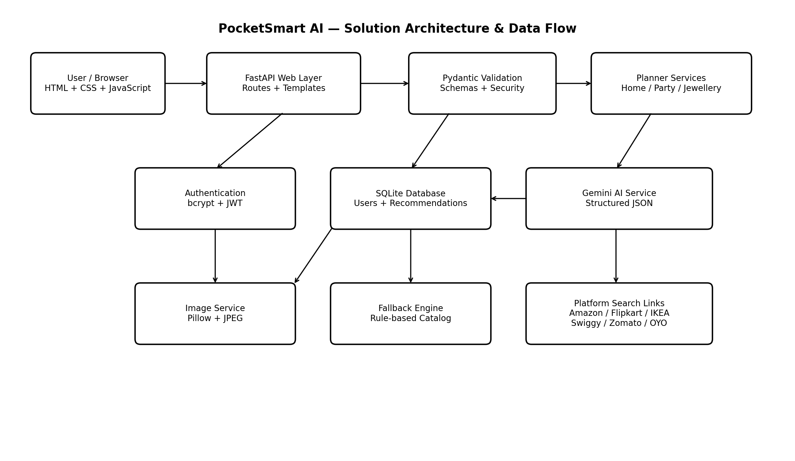
Figure 1: PocketSmart AI solution architecture and logical data flow

3.1 Architecture Layers
Layer | Implementation | Responsibility
Presentation Layer | Jinja2 templates, HTML, CSS, JavaScript | User forms, dashboard, planner screens, history and recommendation display
Routing/API Layer | FastAPI routes | HTTP endpoints, authentication dependencies, request handling and responses
Validation Layer | Pydantic schemas | Budget, text, quantity, room, guest and jewellery input validation
Security Layer | bcrypt + PyJWT | Password hashing, JWT creation/validation and authenticated ownership checks
Service Layer | gemini_utils.py, catalog.py, images.py | AI generation, fallback recommendations, budget normalisation, search links and image processing
Persistence Layer | SQLite database.py | Users and recommendation records with foreign keys and indexes
External Services | Google Gemini + shopping/service platforms | AI generation and external search destinations

3.2 Main Data Flow
- User opens PocketSmart AI and registers or logs in.
- Successful login creates a JWT-backed session stored in the access_token cookie; API clients can also use Bearer authentication.
- User opens Home, Party or Jewellery Planner.
- Planner input is submitted to the appropriate FastAPI generation endpoint.
- Pydantic validates structured requests; jewellery uploads are separately validated by Pillow.
- The AI service builds a category-specific prompt and calls the configured Gemini model.
- Gemini output is parsed from JSON and normalised into the application's expected result structure.
- If Gemini is unavailable, fails or returns invalid content, the corresponding rule-based fallback service is used.
- The application calculates item totals, section allocations and estimated total and applies budget safeguards.
- Search links are generated using a fixed platform catalogue.
- The final recommendation is stored in SQLite against the authenticated user.
- The user is redirected to the saved recommendation and can later view/filter/delete it from history.

3.3 Database Design
Table | Important Fields | Relationship / Purpose
users | id, username, email, password_hash, created_at | One user can own many recommendations
recommendations | id, user_id, category, title, budget, inputs_json, result_json, source, created_at | Stores generated plans and their source (AI or fallback)
The recommendations.user_id field references users.id with ON DELETE CASCADE. An index on user_id and created_at supports recent-history queries.

3.4 Security Architecture
- Passwords are hashed using bcrypt before storage.
- JWT tokens use HS256 and contain user ID, username, issue time and expiry time.
- Protected HTML pages redirect unauthenticated users to /login.
- Protected API endpoints return HTTP 401 when authentication is missing or invalid.
- Recommendation reads and deletes are scoped by both recommendation ID and authenticated user ID.
- The authentication cookie is HttpOnly and SameSite=Lax.
- Uploaded images are decoded and verified with Pillow, restricted to JPG/PNG/WEBP and limited to 5 MB.
- Uploaded images are converted to JPEG and resized to a maximum 1024×1024 dimension.
- AI-generated URLs are not trusted; the catalog service creates canonical search URLs.

3.5 AI Architecture
AI Stage | Design
Prompt Construction | Separate prompt logic for Home, Party and Jewellery
Model Selection | Configured primary Gemini model followed by configured fallback models
Response Format | Gemini requested to return JSON
Parsing | Handles clean JSON and JSON embedded in markdown/prose
Normalisation | Converts numeric values, limits sections/items and creates expected fields
Budget Control | Recalculates item totals and section totals; over-budget results can be scaled
Failure Handling | Falls back to deterministic catalog recommendations
Jewellery Image | Optional JPEG bytes are supplied to Gemini for outfit-aware recommendations

3.6 Deployment / Runtime Design
Configuration | Current Design
Application Server | Uvicorn / FastAPI
Default Host | 127.0.0.1
Default Port | 8000
Database Path | data/pocketsmart.db unless DB_PATH is configured
Upload Location | static/uploads
AI Key | GEMINI_API_KEY or GOOGLE_API_KEY environment variable
Secret | SECRET_KEY environment variable; temporary generated key if not configured
CORS | Configurable through CORS_ORIGINS
AI Availability | Application starts even when Gemini key is missing because fallback recommendations exist

4. Design Requirements Summary
Requirement Area | Design Decision
Usability | Three clear planner workflows with dashboard and history
Personalisation | Planner-specific inputs plus optional jewellery outfit image
Reliability | AI fallback engine
Security | bcrypt, JWT, protected routes and ownership checks
Data Integrity | Pydantic validation, SQLite foreign keys and result normalisation
Maintainability | Separated routes, schemas, services, security and database modules
Extensibility | Configurable AI models, platform catalogue and independent planner services

5. Current Limitations
- The application uses SQLite and local file storage, which are appropriate for the project prototype but may not be sufficient for high concurrency.
- AI recommendations depend on external Gemini availability when personalised AI output is required.
- Shopping/service links are search links, not real-time product availability or checkout integrations.
- No payment, subscription, admin or notification modules are currently implemented.
- A production deployment should use HTTPS, a persistent secret, appropriate secure cookie settings, rate limiting and production monitoring.

6. Conclusion
The PocketSmart AI project design provides a practical bridge between the identified budgeting/planning problem and the implemented technology solution. Its architecture combines a browser-based interface, FastAPI services, structured validation, secure authentication, SQLite persistence, Gemini-based AI generation, image processing and deterministic fallback logic. The design is modular enough for future expansion while remaining appropriate for the current academic project implementation.

